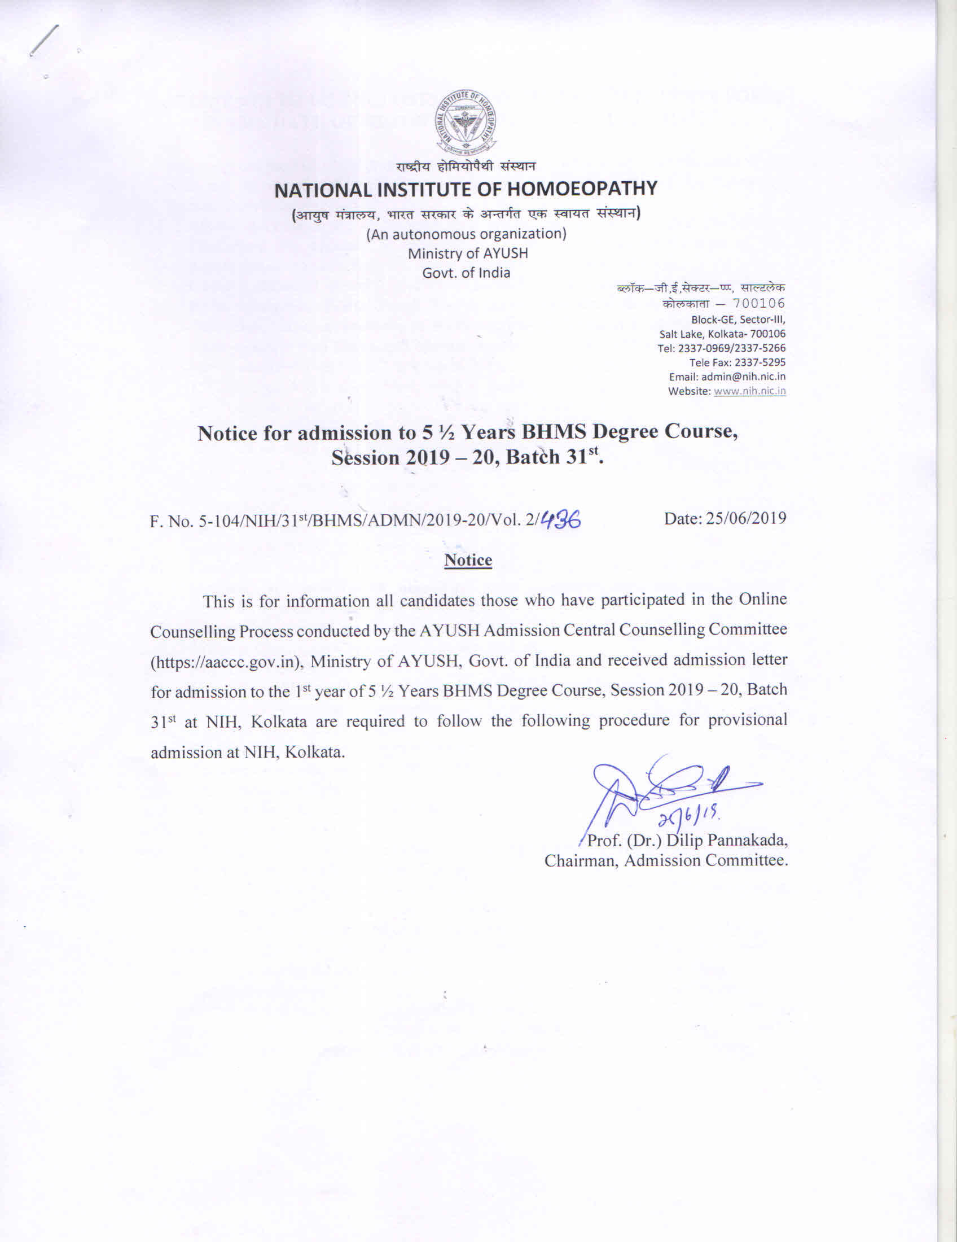

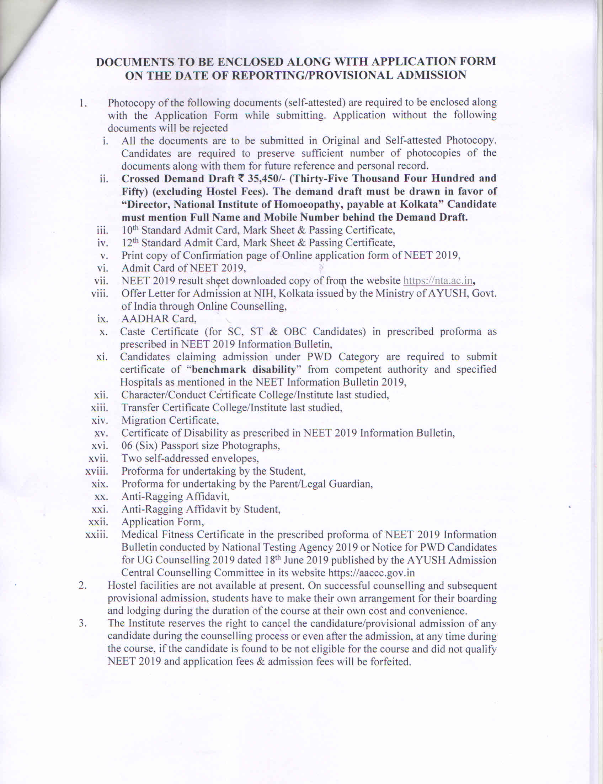

PROFORMA FOR UNDERTAKING BY THE STUDENT

{To be executed by all the candidates provisionally selected for admission to 5½ year BHMS Degree Course (Session 2019-20) typed on `10/- non-judicial stamp paper; and shall be NOTARISED}

Each student seeking admission to 5½ years BHMS Degree Course at National Institute of Homoeopathy and her/his parent/legal guardian is required to submit the under taking on the day of admission to course. I do hereby undertake and declare as follows:
- I,___________________ daughter/son of _______________, having been recommended by the AYUSH Admission Central Counselling Committee for admission to the 1st year of 5½ Years BHMS Degree Course, Session 2019 – 20, Batch 31st at NIH, Kolkata and I have carefully read and fully understood the discipline and duties and general rules of the Institute as well as hostel, described in prospectus [herein after referred as regulations of the Institute]
- I have passed /appeared in (10+2) or its equivalent Examination as prescribed for National Eligibility cum Entrance Test 2019 conducted by National Testing Agency 2019.
- I understand that my candidature is provisional subject to confirmation of my eligibility to NEET 2019 conducted by National Testing Agency 2019.
- I understand that my candidature/provisional selection /admission is liable to be rejected at any time, even after admission and my application fee / admission fee will be forfeited if found that I have not qualified National Eligibility cum Entrance Test 2019 conducted by National Testing Agency 2019 and/or I do not confirm to the eligibility criteria prescribed by the Central Council of Homoeopathy, New Delhi for admission to the 1st year of 5½ Years BHMS Degree Course, Session 2019 – 20, Batch 31st at NIH, Kolkata.
- I have understood what constitutes miss conduct and/ or indiscipline as mentioned in the regulations of the Institute.
- I have made myself aware of the penal and administrative action that may be taken against me in the event I am found abetting indiscipline and/or misconduct, actively or passively or being a part of a conspiracy to promote indiscipline and/or misconduct.
- I do hereby undertake that
- I will not indulge in any behavior or act that may be constituted as indiscipline and/or misconduct.
- I will not participate in or abet or propagate through any act of commission or omission that may be constituted as misconduct and/or indiscipline with reference to Regulations of the Institute.
- I individually or collectively will not interfere or prevent the normal functioning of academic activity; general administration or functioning of hospital (OPD/IPD) affecting patient care.
- I do hereby affirm that, if found guilty of any misconduct and/or indiscipline, I would be liable for punishment according to Regulations of the Institute without prejudice to any other action that may be taken against me as available under the law of land.
- I do hereby declare that I have not been expelled or debarred from admission in any Institution in the Country on the account of found guilty for any misconduct and/or indiscipline, abating or being a part of conspiracy to promote, indiscipline by any authority/Institute of the Country and I further affirm that incase if at any point of time during my study it is found that I have declared falsely or that the declaration contains any untrue statement, my admission shall automatically stand cancelled.
- I do hereby affirm that I have read and understood the contents, purports and implications of the aforesaid declaration. This undertaking is being made out of own volition, in sound my and health and without any undue influence, coercion, force and/or compulsion.
- The statements made in the aforesaid paragraphs are true to the best of my knowledge and belief.
Date: Signature of the deponent
Place: Address: permanent & correspondence
Telephone No.: Landline/Mobile
Email id
Confirmed and agreed to and witnessed by

Signature of the guardian

PROFORMA FOR UNDERTAKING BY PARENT/LEGAL GUARDIAN
(To be typed on a ` 10/- Non-Judicial Stamp Paper; and shall be NOTARISED)
- I _____________________________ father/ mother/ legal guardian of _____________________ having been provisionally admitted to National Institute of Homoeopathy, Kolkata, carefully read and fully understood the discipline and duties and General Rules of the Hostel [herein after referred as Regulations of the Institute] Prospectus.
- My ward have passed/appeared in (10+2) or its equivalent Examination as prescribed for National Eligibility cum Entrance Test 2019 conducted by National Testing Agency 2019.
- I understand that his/her candidature is provisional subject to confirmation of his/her eligibility to NEET 2019 conducted by National Testing Agency 2019.
- I understand that his/her candidature/provisional selection /admission is liable to be rejected at any time, even after admission and my application fee/admission fee will be forfeited if found that he/she has not qualified National Eligibility cum Entrance Test 2019 conducted by National Testing Agency 2019 and/or he/she dose not confirm to the eligibility criteria prescribed by the Central Council of Homoeopathy, New Delhi for admission to the 1st year of 5½ Years BHMS Degree Course, Session 2019 – 20, Batch 31st at NIH, Kolkata
- I have, in particular understood what constitutes indiscipline and/or misconduct with reference to the Regulations of the Institute.
- I have also made myself fully aware of the penal and administrative action that is liable to be taken against my ward in case he/she is found to be abetting indiscipline and/or misconduct actively or passively or being a part of a conspiracy to promote indiscipline and or misconduct.
- I do hereby undertake that
- My ward will not indulge in any behavior or act that may be constituted as misconduct and/or indiscipline with reference to the Regulations of the Institute.
- My ward will not participate or abet or propagate through any act of commission or omission that may be constituted as indiscipline and/or misconduct with reference to the Regulations of the Institute.
- My ward individually and/or collectively will not interfere and/or prevent the normal functioning of academic activity; general administration and/or functioning of hospital (OPD/IPD) affecting patient care.
- I do hereby declare that if my ward is found to be undisciplined, he is liable for punishment according to Regulations of the Institute, without prejudice to any other action that may be taken against him/her under law of the land for the time being in force.
- I do hereby declare that my ward has not been expelled or debarred from admission in any Institution in the country on the account of found guilty of abetting or being a part of a conspiracy to promote misconduct and/or indiscipline; and further affirm that, in case the declaration is found to be untrue, the admission of my ward is liable to be cancelled.
- I do hereby affirm that I have read and understood the full contents, purports and implications of the aforesaid declaration. This undertaking is being made out of own volition, in sound mind and health and without any undue influence, coercion, force and/or compulsion.
- The statements made in the aforesaid paragraphs are true to the best of my knowledge and belief.
Date: Signature of the deponent
Place: Address:
Email id: Telephone No.: Landline/Mobile

ANTI RAGGING AFFIDAVIT
As per University Grants Commission regulations and directions from Hon'ble Supreme the students and parents/ guardians are required to submit affidavit on ` 10/- (Rupees Ten only) non-judicial stamp paper duly notarized at the beginning of the Semester classes with regard to curbing ragging menace. The text of the affidavit attached.

ANTI RAGGING AFFIDAVIT BY PARENT/ GUARDIAN

- I, Mr./Mrs./Ms _____________________________________ Father/Mother/Guardian of, ____________________________________________________ having been admitted to ___________________________________ have received a copy of the UGC Regulations on Curbing the Menace of ragging in Higher Educational Institutions, 2009, (hereinafter called the "Regulation"), carefully read and fully understood the provisions contained in the said Regulations.
- I have, in particular, perused clause 3 of the Regulations and am aware as to what constitutes ragging.
- I have also, in particular, perused clause 7 and clause 9.1 of the Regulations and am fully aware of the penal and administration action that is liable to be taken against my ward in case he/she is found guilty of or abetting ragging, actively or passively, or being part of a conspiracy to promote ragging.
- I hereby solemnly aver and undertake that:
- My ward will not indulge in any behavior or act that may be constituted as ragging under clause 3 of the Regulations.
- My ward will not participate in or abet or propagate through any act of commission or omission that may be constituted as ragging under clause 3 of the Regulations.
- I hereby affirm that, if found guilty of ragging, my ward is liable for punishment according to clause 9.1 of the Regulations, without prejudice to any other criminal action that may be taken against my ward under any penal law or any law for the time being in force.
- I hereby declare that my ward has not been expelled or debarred from admission in any institution in the country on account of being found guilty of, abetting or being part of a conspiracy to promote, ragging; and further affirm that, in case the declaration is found to be untrue, the admission of my ward is liable to be cancelled.
VERIFICATION
Verified that the contents of this affidavit are true to the best of my knowledge and no part of the affidavit is false and nothing has been concealed or misstated therein.

Date: Signature of the deponent
Place: Address:
Telephone No.: Landline/Mobile
Email id

Solemnly affirmed and signed in my presence on this the ____________________________ (day) of ___ (month), ______ (Year) after reading the contents of this affidavit.

OATH COMMISSIONER

As per University Grants Commission regulations and directions from Hon'ble Supreme the students and parents/ guardians are required to submit affidavit on ` 10/- (Rupees Ten only) non-judicial stamp paper duly notarized at the beginning of the Semester classes with regard to curbing ragging menace. The text of the affidavit attached.

ANTI RAGGING AFFIDAVIT BY STUDENT
- I, ____________________________________________________________ S/o Mr./Mrs./ Ms.____________________________________________________, having been admitted to________________________________ (name of the institution) have received a copy of the UGC Regulations on Curbing the Menace of ragging in Higher Educational Institutions, 2009, (hereinafter called the “Regulation”), carefully read and fully understood the provisions contained in the said Regulations.
- I have, in particular, perused clause 3 of the Regulations and am aware as to what constitutes ragging.
- I have also, in particular, perused clause 7 and clause 9.1 of the Regulations and am fully aware of the penal and administration action that is liable to be taken against me in case I am found guilty of or abetting ragging, actively or passively, or being part of a conspiracy to promote ragging.
- I hereby solemnly aver and undertake that:
  - I will not indulge in any behavior or act that may be constituted as ragging under clause 3 of the Regulations.
  - I will not participate in or abet or propagate through any act of commission or omission that may be constituted as ragging under clause 3 of the Regulations.
- I hereby affirm that, if found guilty of ragging, I am liable for punishment according to clause 9.1 of the Regulations, without prejudice to any other criminal action that may be taken against me under any penal law or any law for the time being in force.
- I hereby declare that I have not been expelled or debarred from admission in any institution in the country on account of being found guilty of, abetting or being part of a conspiracy to promote, ragging; and further affirm that, in case the declaration is found to be untrue, I am aware that my admission is liable to be cancelled.

VERIFICATION
Verified that the contents of this affidavit are true to the best of my knowledge and no part of the affidavit is false and nothing has been concealed or misstated therein.
Place: Signature of deponent
Date: Address:
Telephone/ Mobile No.:
Solemnly affirmed and signed in my presence on this the |  |  |  |  | (day) of
 | (month), |  | (year) after reading the contents of this affidavit.

OATH COMMISSIONER

BOND BY STUDENT (IF MINOR, BY HIS/HER GUARDIAN)

[To be executed by all the candidates (or guardian as the case may be), provisionally selected for admission to BHMS Course (Session 2019-20) on ` 100/- non-judicial stamp paper (notarised)]

KNOW ALL MEN that I, .........................................................................................................., (or guardian of student), the undersigned, a student/guardian of ........................................... ............................................................................................................................................. (name of student) provisionally admitted to BHMS Course (Session 2019-20) of National Institute of Homoeopathy, Salt Lake, Kolkata – 700 106, bind myself to National Institute of Homoeopathy, Kolkata, for payment to the National Institute of Homoeopathy a sum of ` 50,000/- (Rupees Fifty thousand only) as compensation, in case I (in case guardian – my ward) do/ does not prosecute with the Course during any stage of study over and above the admission fees already paid at the time of admission.
Signed by (Full Name) ....................................................................Signature .................................................
Address............................................................................................................................................................................................................................. on …………………………………………. this ……………………………………day of……………………………….

Witness

1. Signature (in full) 2. Signature (in full)
Name and address Name and address

Mobile No.
Email ID: |  |  | Email ID:
Pin Code |  |  | Pin Code
Police Station |  |  | Police Station

Sureties

1. Signature (in full) 2. Signature (in full)
Name and address Name and address

Mobile No.
Email ID: |  |  | Email ID:
Pin Code |  |  | Pin Code
Police Station |  |  | Police Station

NATIONAL INSTITUTE OF HOMOEOPATHY
(An autonomous organization) Ministry of AYUSH, Govt. of India
Block GE, Sector III, Salt Lake, Kolkata 700106.website: www.nih.nic.in
APPLICATION FORM

FOR ADMISSION TO 5½ YEARS BHMS DEGREE COURSE
SESSION 2019 – 20, Batch 31st

- Full name of the Candidate:
(in Block Letters as indicated in NEET 2019 Online Application):
Photo
- Father’s/Guardian’s Name (if father is not Guardian):
- Address for Correspondence
with Pin Code and State (in Capital Letters only):
- Permanent Address
with Pin Code and State (in Capital Letters only):
- Valid Mobile Number (as indicated in NEET 2019 Online Application):
- Valid Email ID (as indicated in NEET 2019 Online Application):
- Whether Schedule Caste/Schedule Tribe/OBC/General:
(as indicated in NEET 2019 Online Application)
- Whether Physically Challenged:
(as indicated in NEET 2019 Online Application)
- Details of Bank Draft submitted: Name of the Bank and Branch___________ Demand Draft No.___________ for ` 1000/- dated _______
- Name of the Educational Board or Council under which appeared for 10+2 or equivalent examination:
- Declaration by Candidate: I certify that
- I am an Indian National/ I am not an Indian National
- I have passed /appeared in (10+2) or its equivalent Examination as prescribed for National Eligibility cum Entrance Test 2019 conducted by National Testing Agency 2019.
- I understand that my candidature is provisional subject to confirmation of my eligibility to NEET 2019 conducted by National Testing Agency 2019.
- I understand that my candidature/provisional selection /admission is liable to be rejected at any time, even after admission and my application fee / admission fee will be forfeited if found that I have not qualified National Eligibility cum Entrance Test 2019 conducted by National Testing Agency 2019 and/or I do not confirm to the eligibility criteria prescribed by the Central Council of Homoeopathy, New Delhi for admission to the 1st year of 5½ Years BHMS Degree Course, Session 2019 – 20, Batch 31st at NIH, Kolkata

Date………..

Place: …………………. Full Signature of Candidate

